

BEng(Hons) Software Engineering

Module Name | 4COSC006C- Software Development -I
Module Leader | Mr. Guhanathan Poravi
Assessment Type | Individual
Assessment Number | Stage 02
Student ID | 20231970 – IIT  W2149655 – UoW
Student Name | Mr. K. M. Palansuriya
Issue Date | Tuesday 19th Feb 2025
Submission Date | Thursday 27th Mar 2025
Table of Contents
Test Cases for File Handling Operations 3
Test Cases and Results 3
Test Case 01 – Add Task 3
Test Case 02 – View Tasks 5
Test Case 03 – Update Tasks 7
Test Case 04 – Delete Tasks 9
Test Case 05 – Exit 11

Table 1-Test case 01-Add task 3
Table 2-Test Case 02-(View-Tasks) 5
Table 3-Test Case 03-(update tasks) 7
Table 4-Test Case 04- (Delete Tasks) 9
Table 5-Test Case 05-(Exit) 11

Figure 1-Test Case 01 (txt file) 5
Figure 2-Test Case 02-(txt file) 6
Figure 3-test case 03-(txt file) 8
Figure 4-Test case 04-(txt file) 10

Test Case 1-(Screenshot) 4
Test Case 2-(Screenshot) 7
Test Case 3-(Screenshot) 8
Test Case 4-(Screenshot) 10
Test Case 5-(Screenshot) 11

Test Cases for File Handling Operations

Test Cases and Results

Test Case 01 – Add Task

Table 1-Test case 01-Add task
Test  Case | Input | Expected  Outcomes | Actual  Outcomes | Result
Add Task | Task 01, SD01,  Tutorial 1, high,  2025-03-28 | Task added successfully, Task list updated and saved to the txt file | Task added successfully, Task list  Updated and saved to the txt file | Pass

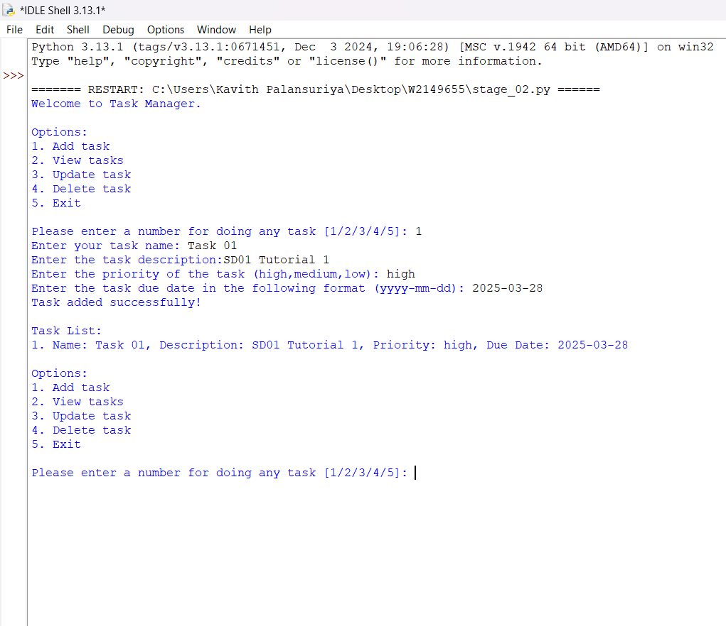
Test Case 1-(Screenshot)

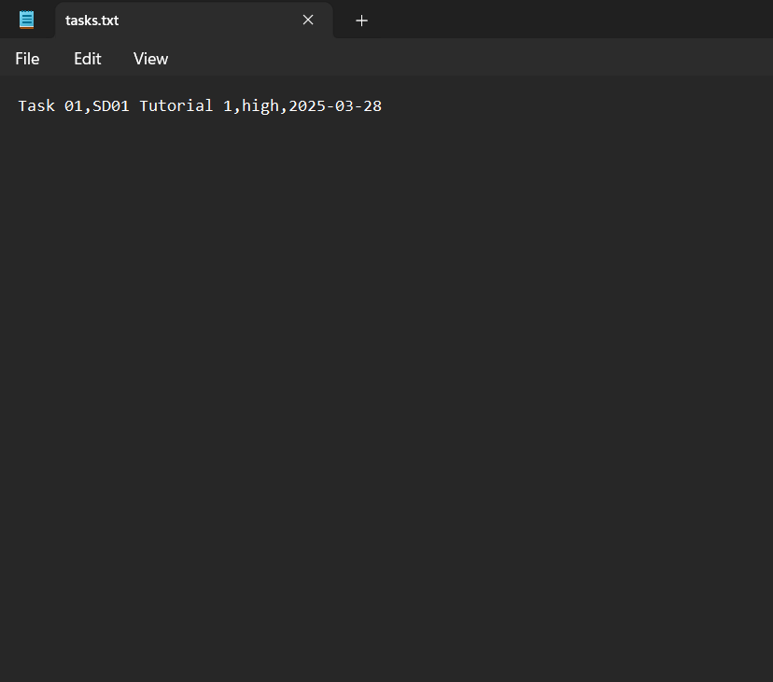
Figure 1-Test Case 01 (txt file)

Test Case 02 – View Tasks

Table 2-Test Case 02-(View-Tasks)
Test  Case | Input | Expected  Outcomes | Actual  Outcomes | Result
View  Tasks | User to input option 2 view tasks | Task 01 is displayed in the idle shell and the txt file | Task 01 is displayed in both idle and txt file | Pass


Figure 2-Test Case 02-(txt file)

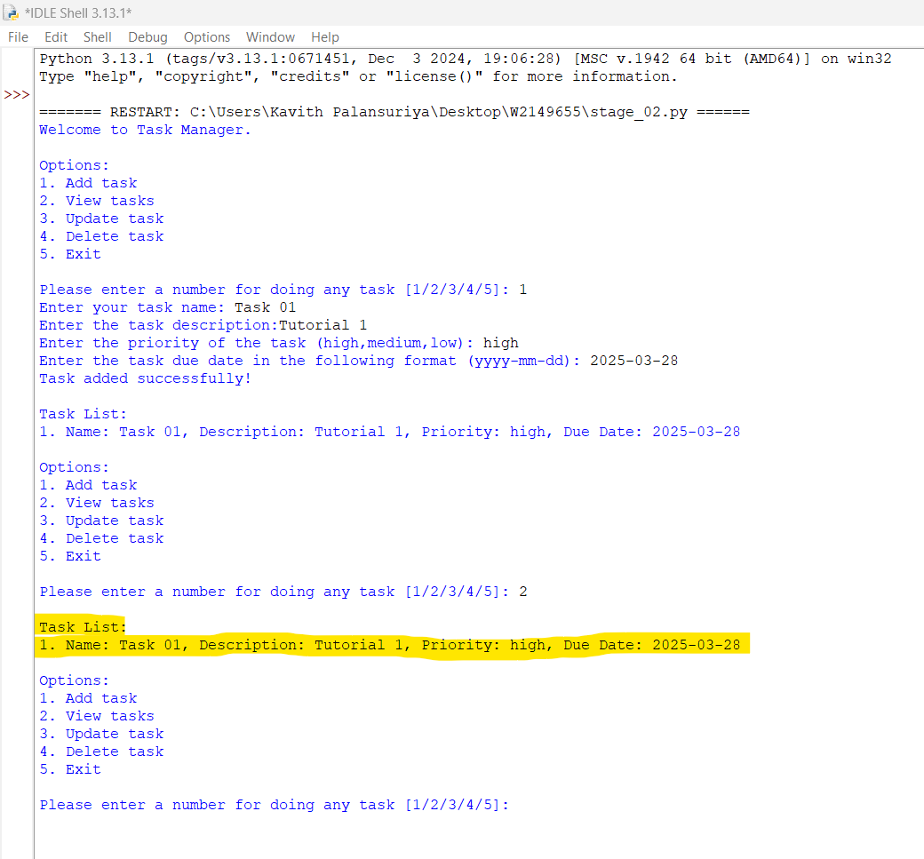
Test Case 2-(Screenshot)

Test Case 03 – Update Tasks

Table 3-Test Case 03-(update tasks)
Test  Case | Input | Expected  Outcomes | Actual  Outcomes | Result
Update  Task | Modify Task 01 to new tasks such as Task 02, SD01 Tutorial 2, medium | Old tasks convert into new task using update tasks, task name, description and priority  Should updated | New task updated | Pass
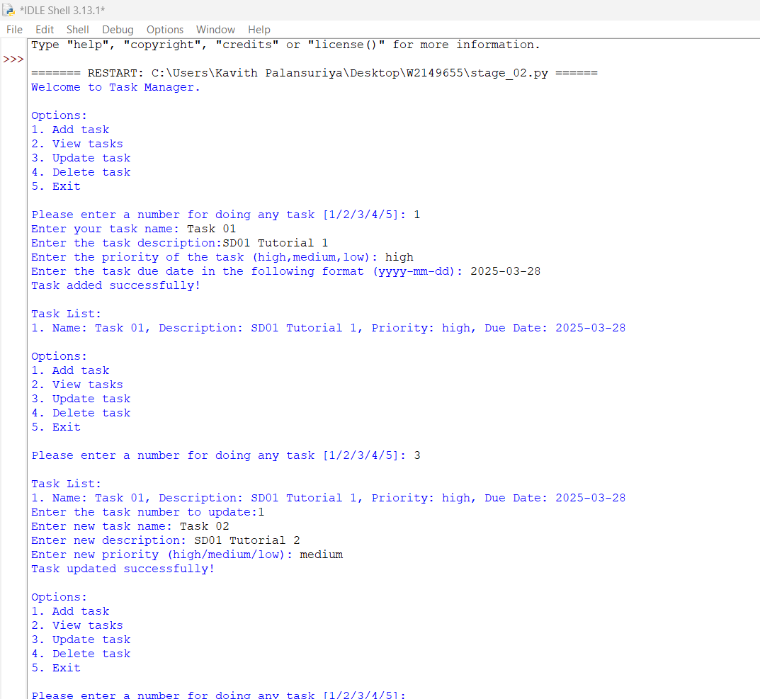
Test Case 3-(Screenshot)

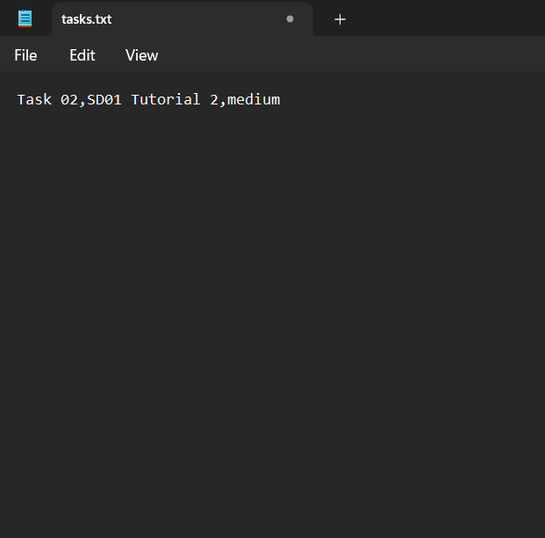
Figure 3-test case 03-(txt file)

Test Case 04 – Delete Tasks

Table 4-Test Case 04- (Delete Tasks)
Test  Case | Input | Expected  Outcomes | Actual  Outcomes | Result
Delete  Task | Enter to user “option 5” it will show the number of tasks list in there and user to enter task number it will delete task 01 | Task should be removed from the idle shell and the txt file | Task deleted successfully | Pass

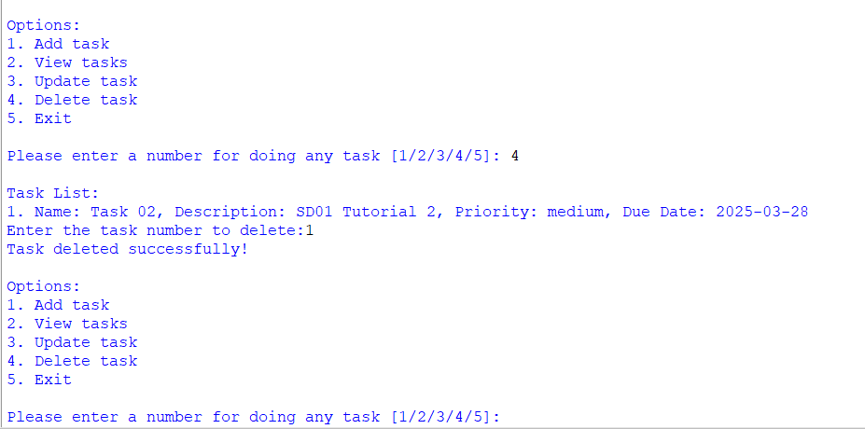
Test Case 4-(Screenshot)
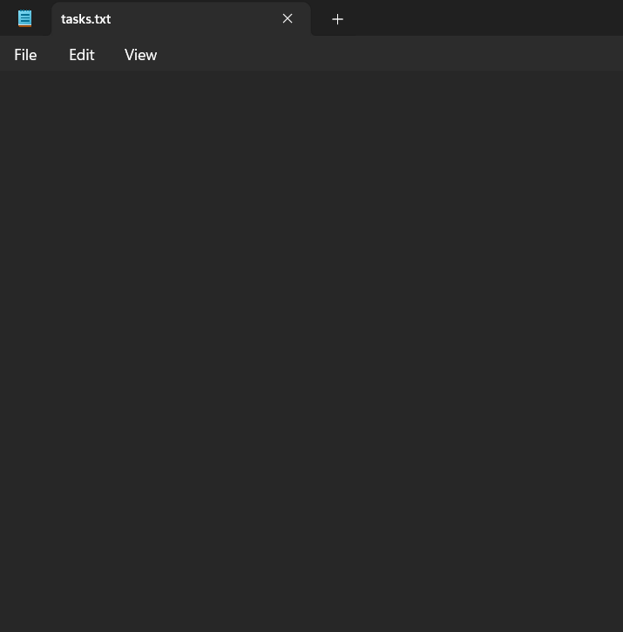
Figure 4-Test case 04-(txt file)

Test Case 05 – Exit

Table 5-Test Case 05-(Exit)
Test  Case | Input | Expected  Outcomes | Actual  Outcomes | Result
Exit | User to enter “option 5” | Program should  exit with a massage | Program exited with ‘Thank you for using the system’ | Pass

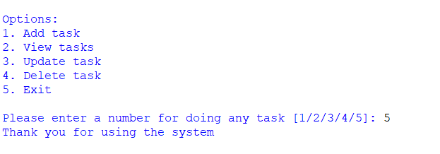
Test Case 5-(Screenshot)

